**JAC444 - Lecture 10**

Networking Programming in Java

Segment 2- Socket Programing

Socket Programming

**In this lesson you will be learning about:**

* Sockets
* How to Build a Java Server
* How to Develop a Java Client-Server Application

**Protocol packets**

Unit of data exchanged between protocol entities in a given layer.

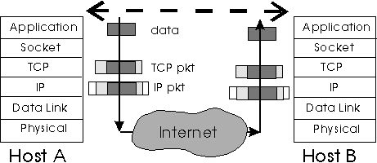

**Socket**

* A *socket* is one endpoint of a two-way communication link between two programs running on the network.
* A socket *is bound to a port number* so that the TCP layer can identify the application that data is destined to be sent.

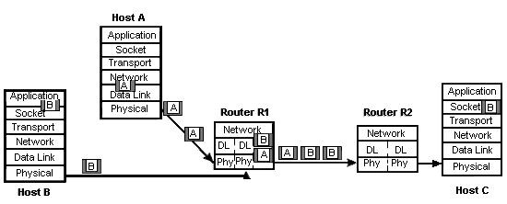

**Socket - IP Address & Port**

The *socket* is defined by two elements: **IP Address** and **Port**

IP Address is the Host IP - Port is a reserved number

Data

Application

Socket

IP

HOST

Port

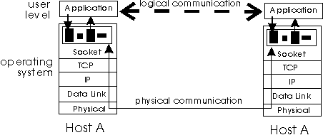

**Client Server Paradigm**

ServerSocket listens for a connection to be made

Clien

t

Server

Socket

Socket

**Server**

IP Address

Host

Socket

Host

IP Address

**1**

**2**

**3**

Reserved Port

**Jordan Anastasiade – Java Programming Language Course 6**

**Conclusion**

**After completion of this lesson you should know:**

* Networking Solution Using Sockets
* Client Server Paradigm
* How to Develop Java Client-Server Applications

**Jordan Anastasiade – Java Programming Language Course 7**